LAB SECTION 2: DOCKER NETWORK

- Objective & Networking Architecture
Docker utilizes software-defined networking to isolate and connect containers. Key characteristics include:

• Default Bridge Network: Legacy default network. Containers can communicate only via static IP addresses. Automatic DNS resolution by container name is not supported.

• User-Defined Custom Bridge: Recommended standard. Activates Docker's embedded DNS server (127.0.0.11), allowing automatic service discovery where containers resolve each other by Container Name as well as direct Container IP.

- Step-by-Step Implementation & Verifications

Step 1: Create a Custom Bridge Network
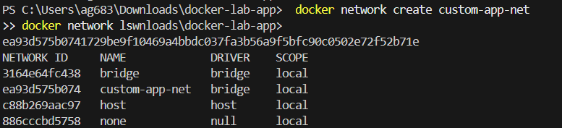

Step 2: Start Two Containers Attached to the Custom Network

Step 3: Inspect Network & Retrieve Container IP Addresses

Step 4: Demonstrate Communication using Container Name (DNS Resolution)

Step 5: Demonstrate Communication using Container IP Address
